United States Journal for Hypersonics

(16-point Bold, “Title” in Styles)
Charles A. Lindbergh,¹ Charles E. Yeager,² Neil A. Armstrong³
(11-point Bold, “Author List” in Styles)
¹US Army Air Service, Randolph AFB, San Antonio, TX 78150, ²NACA Muroc Flight Test Unit, Muroc Air Force Base, CA 93523, ³NASA Johnson Space Center, Houston, TX 77058
(11-point, “Author Affiliation” in Styles)
Abstract. Lorem ipsum dolor sit amet, consectetuer adipiscing elit. Nam nibh. Nunc varius facilisis eros. Sed erat. In in velit quis arcu ornare laoreet. Curabitur adipiscing luctus massa. Integer ut purus ac augue commodo commodo. Nunc nec mi eu justo tempor consectetuer. Etiam vitae nisl. In dignissim lacus ut ante. Cras elit lectus, bibendum a, adipiscing vitae, commodo et, dui. Ut tincidunt tortor. Donec nonummy, enim in lacinia pulvinar, velit tellus scelerisque augue, ac posuere libero urna eget neque. Cras ipsum. Vestibulum pretium, lectus nec venenatis volutpat, purus lectus ultrices risus, a condimentum risus mi et quam. Pellentesque auctor fringilla neque.
(500 words or less, 10-point, “Abstract” in Styles)

1. Section (“Heading 1” in Styles)
(U) Lorem ipsum dolor sit amet, consectetuer adipiscing elit. Nam nibh. Nunc varius facilisis eros. Sed erat. In in velit quis arcu ornare laoreet. In in velit quis arcu ornare laoreet.
(“Body Text” or “USJH” in Styles)

1.1 Subsection (“Heading 2” in Styles)
(CUI) Lorem ipsum dolor sit amet, consectetuer adipiscing elit. Nam nibh. Nunc varius facilisis eros. Sed erat. In in velit quis arcu ornare laoreet. In in velit quis arcu ornare laoreet (Doe et al. 2024).

1.1.1 Subsubsection (“Heading 3” in Styles)
(CUI) Lorem ipsum dolor sit amet, consectetuer adipiscing elit. Nam nibh. Nunc varius facilisis eros. Sed erat. In in velit quis arcu ornare laoreet. In in velit quis arcu ornare laoreet. See Table 1 and Figures 1a and 1b.

(CUI) Table 1: Lorem ipsum dolor
A | B | C | D | E
1 | 2.2 | 3.33 | 4.444 | 5.5555
1 | 2.2 | 3.33 | 4.444 | 5.5555
1 | 2.2 | 3.33 | 4.444 | 5.5555
(Caption above, 10-point Bold. “Caption” in Styles, “Body Text 2” for table entries)

(a) 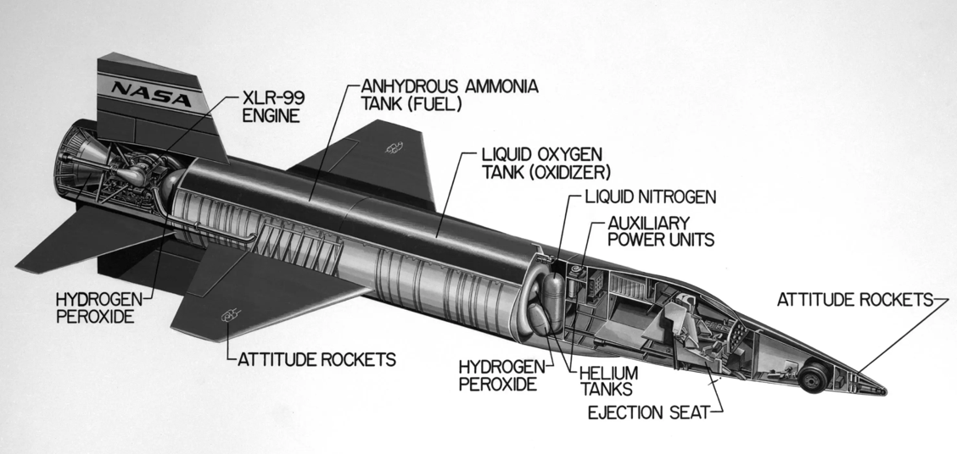
(b) 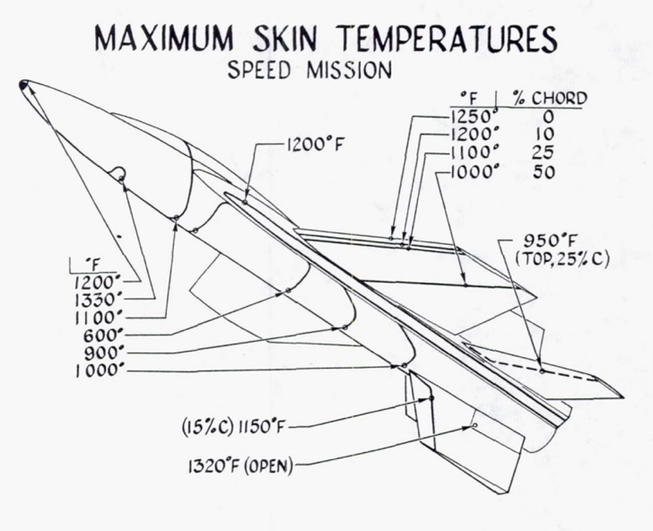
(U) Figure 1: X-15. (a) Schematic (Stillwell 1965). (b) Aero-heating data (Kinsler 1958).
(Caption below figure, 10-point Bold, “Caption” in Styles, Figure legends and labels: 8 point minimum, color figures are encouraged)
(U) Lorem ipsum dolor sit amet, consectetuer adipiscing elit. Nam nibh. Nunc varius facilisis eros. Sed erat. In in velit quis arcu ornare laoreet. In in velit quis arcu ornare laoreet.

2. Section 2
(U) Lorem ipsum dolor sit amet, consectetuer adipiscing elit. Nam nibh. Nunc varius facilisis eros. Sed erat. In in velit quis arcu ornare laoreet. In in velit quis arcu ornare laoreet.

.
.

5. Acknlowledgement
(U) Lorem ipsum dolor sit amet, consectetuer adipiscing elit. Nam nibh. Nunc varius facilisis eros. Sed erat. In in velit quis arcu ornare laoreet. In in velit quis arcu ornare laoreet.

6. Refererences (“Heading 1” in Styles)
(References in alphabetical order, doi’s optional if available)

(U) Doe, J. P., Smith, J. A., Jones, B. W., “Best Paper Ever,” AIAA Paper 2024-0001, American Institute of Aeronautics and Astronautics, Reston, VA., Jan. 2004.
(U) Feynman, R., QED: The Strange Theory of Light and Matter, Princeton University Press, Princeton, New Jersey, 1985.
(U) Kinsley, M., R., “Effects of Aerodynamic Heating on X-15 Temperatures,” in NACA Proceedings: Research–Airplane–Committee Report on Conference on the Progress of the X - 15 Project, Los Angeles, CA, July 1958, pp. 185 – 195.
(U) Shor, P. W., “Polynomial-Time Algorithms for Prime Factorization and Discrete Logarithms on a Quantum Computer,” SIAM Journal on Computing, Vol. 26, No. 5, June 1996, pp. 1 – 26.
(U) Stillwell, W. H., X-15 Research Results with Selected Bibliography, NASA SP-60, Washington DC,1965.

APPENDIX A: nomenclature (optional)
A First Letter of the Alphabet

Greek
α First Letter of the Greek Alphabet

Superscripts
T Turbulent

Subscripts
$∞$ Freestream

