TEES/JHTO-RPP-2021-003
White Paper

Project Title
Technical Area | Choose an item.
Topic Number | # Choose an item.
Applicant Organization
Primary Technical Point of Contact (POC) | Name:  Organization:  Mailing Address:  Telephone:  Email:
Co-PIs | Name:  Institution:  Name:  Institution:
Primary Business POC | Name:  Organization:  Title:  Mailing Address:  Telephone:  Email:
Total Solution Rough Order of Magnitude (ROM) Price | $
Date of Submission | Click or tap to enter a date.

Table of Contents

Section I: Technical Requirements 1
A. Background and Benefits of Proposed Solutions as related to the Statement of Need 1
B. Technical approach, including clearly defined prototype solution 1
Section II: Bibliography and References Cited 2
Section III: Facilities 3
Section IV: Key Personnel (2 pages maximum) 4
A. Contributions and Significance of each Participant 4
Section V: Security Requirements 6
Section VI: Estimated Pricing 8

Section I: Technical Requirements (3 pages maximum)

Background and Benefits of Proposed Solutions as related to the Statement of Need

Technical approach, including clearly defined prototype solution

Section II: Bibliography and References Cited

Section III: Facilities (2 pages maximum)

Section IV: Key Personnel (2 pages maximum)

Contributions and Significance of each Participant

Participant | Participant Contribution & Significance to Overall Project
Name:  Institution: | What are the significant contributions:  Why is the contribution significant:  How is the participant uniquely qualified:
Name:  Institution: | What are the significant contributions:  Why is the contribution significant:  How is the participant uniquely qualified:
Name:  Institution: | What are the significant contributions:  Why is the contribution significant:  How is the participant uniquely qualified:

Participant | Participant Contribution & Significance to Overall Project
Name:  Institution: | What are the significant contributions:  Why is the contribution significant:  How is the participant uniquely qualified:
Name:  Institution: | What are the significant contributions:  Why is the contribution significant:  How is the participant uniquely qualified:
Name:  Institution: | What are the significant contributions:  Why is the contribution significant:  How is the participant uniquely qualified:

Section V: Security Requirements

Institution #1:

A. Address any special security and classification requirements, as necessary.

B. Is your institution, as well as those you are collaborating with, capable of protecting CUI in accordance with the following Defense Federal Acquisition Regulation Supplement (DFARS) clauses:

- DFARS 252.204-7012 ☐ YES ☐ NO
- DFARS 252.204-7019 ☐ YES ☐ NO
- DFARS 252.204-7020 ☐ YES ☐ NO
- DFARS 252.204-7021 ☐ YES ☐ NO

C. Are they able to handle classified research? ☐ YES ☐ NO

D. Are they registered with the Directorate of Defense Trade Controls (DDTC)? ☐ YES ☐ NO

Institution #2:

A. Address any special security and classification requirements, as necessary.

B. Is your institution, as well as those you are collaborating with, capable of protecting CUI in accordance with the following Defense Federal Acquisition Regulation Supplement (DFARS) clauses:

- DFARS 252.204-7012 ☐ YES ☐ NO
- DFARS 252.204-7019 ☐ YES ☐ NO
- DFARS 252.204-7020 ☐ YES ☐ NO
- DFARS 252.204-7021 ☐ YES ☐ NO

C. Are they able to handle classified research? ☐ YES ☐ NO

D. Are they registered with the Directorate of Defense Trade Controls (DDTC)? ☐ YES ☐ NO

Institution #3:

A. Address any special security and classification requirements, as necessary.

B. Is your institution, as well as those you are collaborating with, capable of protecting CUI in accordance with the following Defense Federal Acquisition Regulation Supplement (DFARS) clauses:

- DFARS 252.204-7012 ☐ YES ☐ NO
- DFARS 252.204-7019 ☐ YES ☐ NO
- DFARS 252.204-7020 ☐ YES ☐ NO
- DFARS 252.204-7021 ☐ YES ☐ NO

C. Are they able to handle classified research? ☐ YES ☐ NO

D. Are they registered with the Directorate of Defense Trade Controls (DDTC)? ☐ YES ☐ NO

Institution #4:

A. Address any special security and classification requirements, as necessary.

B. Is your institution, as well as those you are collaborating with, capable of protecting CUI in accordance with the following Defense Federal Acquisition Regulation Supplement (DFARS) clauses:

- DFARS 252.204-7012 ☐ YES ☐ NO
- DFARS 252.204-7019 ☐ YES ☐ NO
- DFARS 252.204-7020 ☐ YES ☐ NO
- DFARS 252.204-7021 ☐ YES ☐ NO

C. Are they able to handle classified research? ☐ YES ☐ NO

D. Are they registered with the Directorate of Defense Trade Controls (DDTC)? ☐ YES ☐ NO

Section VI: Estimated Pricing ** (Please use Excel template provided.)

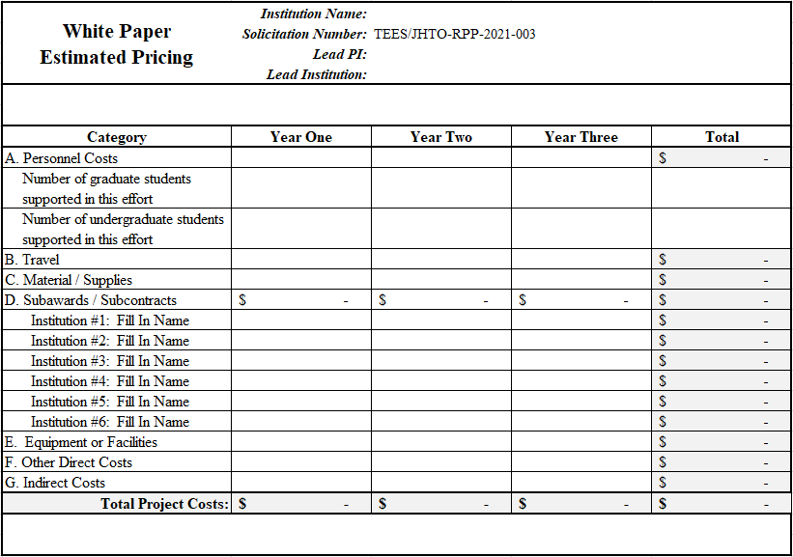
SAMPLE

